HOUGH TRANSFORM AND HARRIS
CORNER DETECTION
Ex No : 8
Date :
AIM :
To perform hough line transform and harris corner detection .
FUNCTIONS :
- cv2.imread():
Reads an image from the specified path and loads it in grayscale.
- cv2.Canny():
Applies the Canny edge detection algorithm to detect edges in the image based on intensity gradients.
- cv2.HoughLines():
Detects lines in an edge-detected image using the Hough Line Transform.
- np.cos():
Calculates the cosine of the angle (used to calculate the direction of the detected lines).
- np.sin():
Calculates the sine of the angle (used to calculate the direction of the detected lines).
- cv2.line():
Draws a line on an image from two given points with a specified color and thickness.
- cv2.cornerHarris():
Detects corners in an image using the Harris Corner Detection algorithm.
- cv2.dilate():
Dilates the corner response image to enhance the corner points.
ALGORITHM :

Hough Line Transform :
- Read Image: Load the grayscale image using cv2.imread().
- Apply Canny Edge Detection: Use cv2.Canny() to detect edges in the image.
- Detect Lines using Hough Transform: Apply cv2.HoughLines() to detect lines in the edge-detected image.
- Initialize a Blank Image: Create an empty image (line_image) to draw the detected lines.
- Draw Detected Lines:
  - For each detected line, compute the line's parameters (r, θ) and convert them to endpoints (x1, y1) and (x2, y2).
  - Use cv2.line() to draw each line on the blank image.
- Display Results:
  - Plot the original image and the image with detected lines using matplotlib.

Harris Corner Detection :
- Read Image: Load the grayscale image using cv2.imread().
- Apply Harris Corner Detection: Use cv2.cornerHarris() to compute the Harris corner response.
- Dilate the Corner Response: Apply cv2.dilate() to highlight the corners more clearly.
- Convert Image to Color: Convert the grayscale image to a color image using cv2.cvtColor().
- Mark Detected Corners: Mark the detected corners in red by modifying the color image at locations where the corner response exceeds a threshold.
- Display Results:
  - Plot the image with the detected corners using matplotlib.

CODE SNIPPET :
import cv2
import numpy as np
import matplotlib.pyplot as plt

image = cv2.imread("C:/Users/student/Downloads/istockphoto-1472606574-612x612.jpg", cv2.IMREAD_GRAYSCALE)

edges = cv2.Canny(image, 50, 150, apertureSize=3)

lines = cv2.HoughLines(edges, 1, np.pi / 180, 150)

line_image = np.zeros_like(image)

if lines is not None:
for line in lines:
r, theta = line[0]
a = np.cos(theta)
b = np.sin(theta)
x0 = a * r # x0
y0 = b * r # y0
x1 = int(x0 + 1000 * (-b))
y1 = int(y0 + 1000 * (a))
x2 = int(x0 - 1000 * (-b))
y2 = int(y0 - 1000 * (a))

cv2.line(line_image, (x1, y1), (x2, y2), (255), 1)

plt.figure(figsize=(10, 5))

plt.subplot(1, 2, 1)
plt.imshow(image, cmap='gray')
plt.title('Original Image')
plt.axis('off')

plt.subplot(1, 2, 2)
plt.imshow(line_image, cmap='gray')
plt.title('Detected Lines (Hough Transform)')
plt.axis('off')

plt.show()

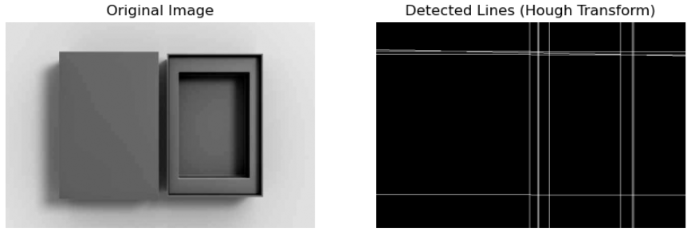

import cv2
import numpy as np
import matplotlib.pyplot as plt

image = cv2.imread("C:/Users/student/Downloads/istockphoto-1472606574-612x612.jpg", cv2.IMREAD_GRAYSCALE)

dst = cv2.cornerHarris(image, 2, 3, 0.04)

dst = cv2.dilate(dst, None)

image_with_corners = cv2.cvtColor(image, cv2.COLOR_GRAY2BGR)
image_with_corners[dst > 0.01 * dst.max()] = [0, 0, 255]

plt.figure(figsize=(8, 8))
plt.imshow(image_with_corners)
plt.title('Harris Corner Detection')
plt.axis('off')
plt.show()

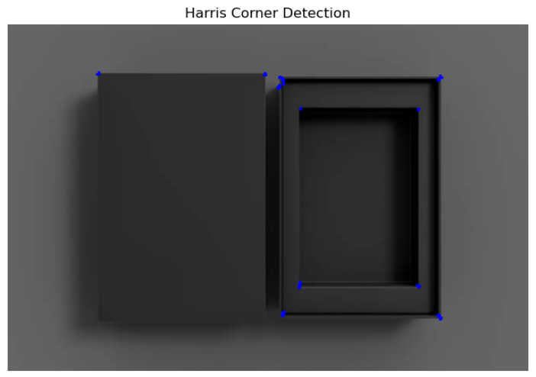

RESULT :
Thus , hough line transform and harris corner detection was performed successfully .

